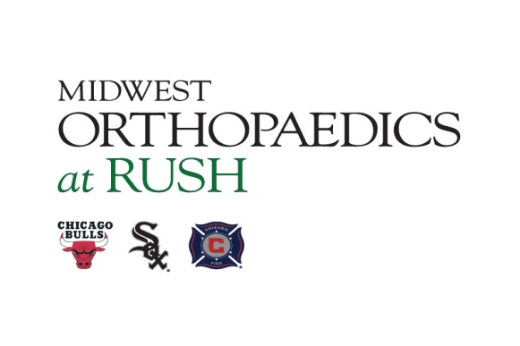
FOR IMMEDIATE RELEASE
Contact: Ann Pitcher
PS Medical Marketing
630-234-4150
Ann@pscommunicationsinc.com

Dr. Nikhil N. Verma Named Head Team

Physician for Chicago White Sox

Chicago, IL, Feb. 15, 2017 - – Nikhil N. Verma, M.D., an orthopedic surgeon and sports medicine physician with Midwest Orthopaedics at Rush (MOR), has been named head team physician for the Chicago White Sox. Dr. Verma will take over the reins for Charles Bush-Joseph, M.D., who has been head team physician since 2003 and is stepping down to assume the roles as incoming president of the American Orthopaedic Society for Sports Medicine, AOSSM, and board member of Rush Health.
Dr. Verma is Director, Division of Sports Medicine for the Department of Orthopedic Surgery at Rush University Medical Center. He is also Fellowship Director for Sports Medicine, overseeing the training of five Rush sports medicine fellows, and Professor and Director of Clinical Research, Sports Medicine Section, Rush University Medical Center.
Dr. Verma has received national recognition for his treatment of shoulder, elbow and knee conditions using advanced and innovative surgical techniques. He performs more than 600 surgical procedures annually, in addition to serving as a team physician for the Chicago White Sox, Chicago Bulls and Nazareth Academy, LaGrange Park.
His clinical practice is complemented by his distinguished work in research and academic medicine. Dr. Verma has written many book chapters and more than 80 peer-reviewed manuscripts that have been published in orthopedic and sports medicine journals. He is often an invited speaker or guest surgeon for national and international sports medicine conferences. Additionally, he is the Associate Editor of the Arthroscopy Journal, as well as a member of the editorial board for the Journal of Knee Surgery. Since 2007, he has been elected annually by his peers to “Best Doctors in America,” and U.S. News & World Report voted him among the top 10 to 15 percent of Top Doctors in America®. Dr. Verma also has been selected AOSSM program chairman for 2018.
About Midwest Orthopaedics at Rush
Midwest Orthopaedics at Rush (MOR) offers comprehensive, unparalleled, orthopedic services. MOR physicians are team physicians for the Chicago Bulls, Chicago White Sox, and the Chicago Fire Soccer Club. They are known for treating patients with orthopedic conditions, ranging from the most common to the most complex. The group’s reputation as a leader in specialized orthopedic patient care, education and research has been recognized by many national publications. U.S. News & World Report ranks the orthopedic program at Rush University Medical Center, Chicago, as No. 4 in the nation and it is the highest ranked program in Illinois. MOR has offices at Rush University Medical Center in Chicago; Oak Park; Westchester; Winfield; and Northwest Indiana. For more information or to make an appointment, visit www.rushortho.com. Follow us on Twitter @mor_docs.

###

